Air Quality Sensor Data Analysis
COMP5048 Assignment 2

Kavvin Udhayakumar Valarmathi
Student ID number
Yan
Student ID number
Caroline
Student ID number
Xueqi Bao
Student ID number
Group: 5048-CC-03-G06
Tutor: Wilma

Task 1

Data and Preprocessing
We used the Air Quality dataset from the UCI repository [1]. It contains hourly averaged responses of a metal-oxide multisensor device placed at road level in an Italian city, together with reference analyser values and weather readings [2]. The file has 9,357 hourly records from 10 March 2004 18:00 to 4 April 2005 14:00, with no duplicate or missing timestamps, and 13 value columns. Missing values are coded as −200.
Before cleaning, we checked the raw file ourselves. The main findings were:
- −200 is the only missing code. CO(GT) is 18.0% missing, NOx(GT) and NO2(GT) 17.5%, NMHC(GT) 90.2% (valid only until 1 May 2004) and every other column 3.9%.
- Missing values are not random. All sensor columns, C6H6, T, RH and AH go missing together (366 hours), 31 hours have no data at all, NOx and NO2 are missing at 03:00 on 93% of days and CO at 04:00 on 54% of days.
- C6H6(GT) is almost a perfect function of PT08.S2(NMHC) (Spearman 0.99998): the same S2 value always gives the same C6H6 value within 0.1.
- AH matches the water vapour pressure (kPa) calculated from T and RH, so it is a derived column.
- NOx(GT) is in ppb, while NO2(GT) is in µg/m³.
- The sensors drift, as reported in [2]. At a fixed NOx level, the PT08.S3 response ranges from about 620 to 923 depending on the month, and PT08.S4 follows T and AH (r = 0.56 and 0.63) more than NO2 (r = 0.16).
Our cleaning script reads the CSV (semicolon separator, decimal comma), drops 114 blank rows and two empty columns, builds one hourly timestamp and replaces −200 with NaN. Nothing is imputed. The script then checks that no rows were lost and no −200 remains, that the number of NaNs in each column equals the number of −200 values in the raw file, and that all other values are unchanged.

Attribute Selection
We selected the timestamp, CO(GT), C6H6(GT), NOx(GT), NO2(GT), PT08.S1(CO), PT08.S5(O3), T and RH (nine attributes) and used them in every task. This covers true concentrations, sensor responses and the environment. We left out NMHC(GT) because it is mostly missing, AH because it is derived from T and RH, PT08.S2 because it duplicates C6H6, and PT08.S3 and PT08.S4 because they showed the strongest drift and temperature effects. Views that show all attributes at once need complete hours, which gives 6,941 hours (74%). October 2004 is the weakest month, at 50%.
Some attributes overlap. C6H6 and CO are strongly related (r = 0.93), and S1 and S5 both follow CO (r = 0.88 and 0.85). A group defined by high CO, C6H6, S1 and S5 is therefore one traffic signal seen several times, not four separate factors, and we describe the groups with this in mind.

Visual Analytic Tool
We built our own web application with four linked views. All views use the same 6,941 complete hours, and the hour of day, weekday, month and season are derived from the timestamp.
- Parallel coordinates [3] is the main view. Each hour is one line, so hours with similar profiles form bundles, and the axes a bundle passes through show which attributes define it. Lines can be coloured by season, time of day (four 6-hour bands), weekday/weekend or saved group.
- A scatterplot of any two attributes shows separation and density for a pair.
- A daily heatmap, with one row per day, shows the daily median of each attribute by colour lightness and cell width, so groups of days stand out.
- A group panel shows, for each hour of day, weekday and month, the share of hours in that slot that belong to a group, together with the group medians.
The axes are ordered analysers, then sensors, then T and RH, so related pollutants sit next to each other and bundles appear as parallel lines. Axes can be dragged to reorder them. Each axis spans the 1st to 99th percentile with its raw end values labelled, because with the full range a few extreme hours pushed most lines to the bottom. The ranges stay fixed when filtering, so views can be compared. With almost 7,000 lines we used low opacity and a fixed random drawing order, so that no season is always drawn on top, and clicking a legend entry shows only that category’s lines. We checked the colours for colour-blind safety; only three passed every pair, so the tool allows three saved groups.
Following “overview first, zoom and filter, then details-on-demand” [4], the user starts from all hours, filters by date, season, month, day type and hour, and then selects hours by brushing ranges on one or more axes, dragging a box in the scatterplot or clicking days in the heatmap. The selection is highlighted in all views and can be saved as a group with its own colour and a thick median line. No clustering algorithm was used; the groups were found only by looking at the views and brushing.

Discovery of Groupings
We first coloured the parallel coordinates by season and showed one season at a time (Fig. 1). Winter lines sit at the bottom of T and the top of RH, and many reach high on NO2. Summer lines meet at the top of T and the bottom of RH, and drop to the floor of the NOx axis. Autumn held most of the lines running along the top of every pollutant and sensor axis. Colouring by time of day showed night lines (00–05) along the bottom of all pollutant axes and afternoon lines (12–17) in the hot, dry bundle.
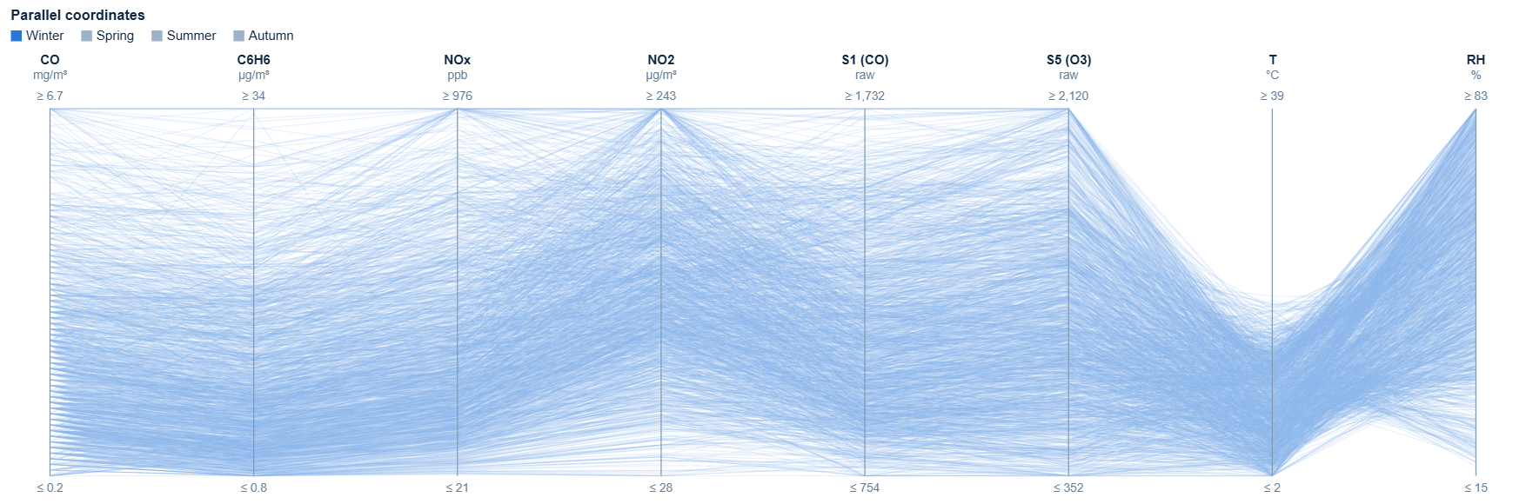
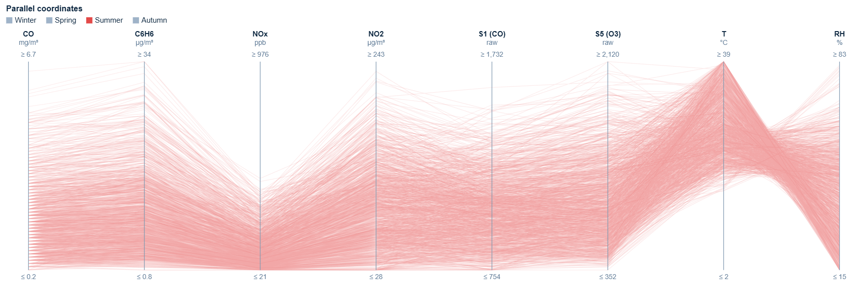
- Parallel coordinates showing only winter (top) and only summer (bottom).
We then brushed each bundle where it sits on the axes:
- Group A: the upper half of the CO axis (CO ≥ 3.5 mg/m³), where lines also stay high on the other pollutant and sensor axes;
- Group B: the bottom band of CO and NOx (CO ≤ 0.9 mg/m³ and NOx ≤ 90 ppb), where the night lines are;
- Group C: the top third of T and the bottom of RH (T ≥ 26 °C and RH ≤ 35%);
- Group D: the lower part of T (T ≤ 10 °C).
A, B and C were saved as groups (Fig. 2), and D was kept as the current selection because the tool allows three saved groups. Table I summarises the groups using the group panel (Fig. 3). The percentages are the bar heights in that panel; for example, 36% at 08:00 means that 108 of the 303 complete hours at 08:00 belong to Group A.
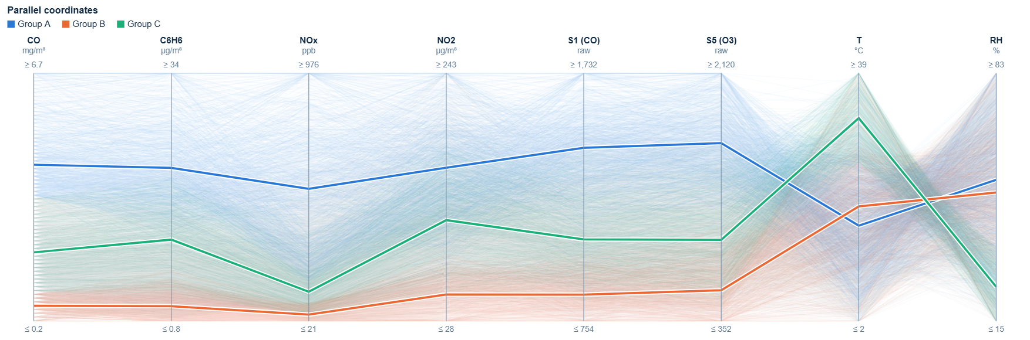
- Parallel coordinates coloured by saved group. Thick lines are the group medians.
- Groups Found in the Parallel Coordinates
Group | Brush | Hours | Defining attributes | Time periods
A: traffic peaks | CO ≥ 3.5 | 1,172 (17%) | High on all pollutant and sensor axes. Medians CO 4.3, C6H6 22, NOx 531, NO2 161 (all hours: 1.9, 8.8, 186, 110). T and RH typical | 08–09 (36–37%) and 18–20 (44–51%). Tue–Fri 22–24%, Mon 14%, Sat 9%, Sun 4%. Almost none in Aug 2004 (1 hour); highest Oct–Nov 2004 (29–31%)
B: clean nights | CO ≤ 0.9, NOx ≤ 90 | 855 (12%) | Floor of all pollutant and sensor axes. Medians CO 0.6, C6H6 2.8, NOx 46, NO2 51 | 02–06 (64% at 04–05). Sun 24% vs 8–14% on other days. Mostly Apr–Aug 2004 (16–29%); rare Oct 2004–Mar 2005 (4–7%)
C: hot, dry afternoons | T ≥ 26, RH ≤ 35 | 906 (13%) | High T (median 33 °C), low RH (24%) and low NOx (134); CO and NO2 typical | 10:00–20:00 (28–32% at 12–17). All days 11–16%. May–Sep 2004, peak Jul 2004 (53%); none Oct 2004–Feb 2005
D: cold, humid hours | T ≤ 10 | 1,431 (21%) | Low T (6.6 °C), higher RH (57%), high NOx (254) and NO2 (131) but CO below typical (1.6) | Mostly 00–09 (25–34%, except 03:00) vs 9–11% at 12–17. All days similar. Mainly Nov 2004–Mar 2005, peak Feb 2005 (78%)

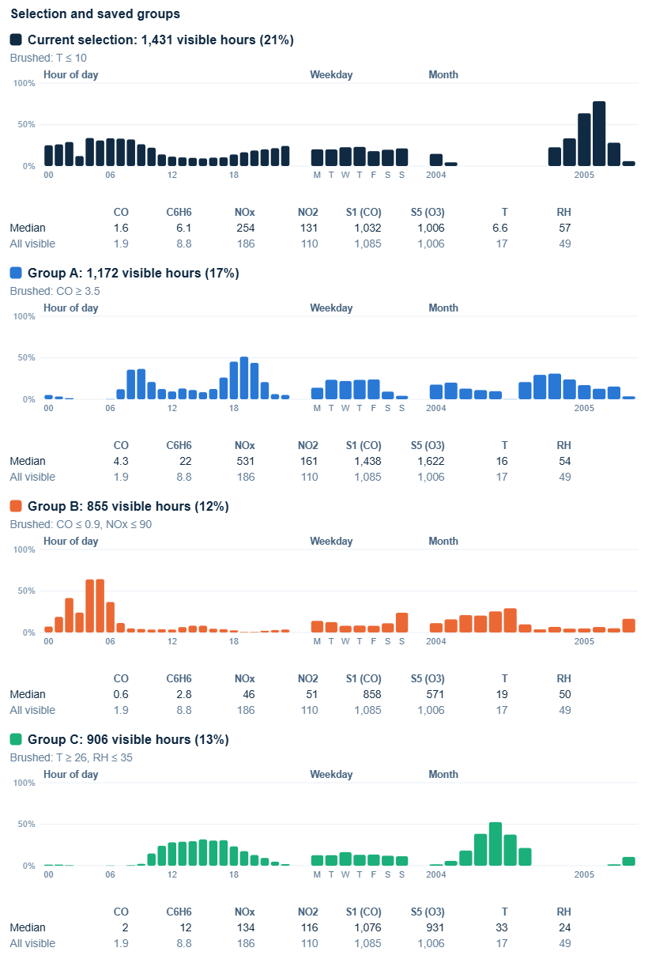
- Group panel: share of hours in each hour of day, weekday and month that belong to each group, with medians. The top card is the cold-hours selection (Group D).

Groupings over Hours and Days
The groups depend on the hour and the day, and the same hour can belong to different groups. Afternoons are often in Group C in summer but never in winter, and early mornings are often in Group B in spring and summer but rarely in winter (Fig. 3). The daily heatmap also shows groups of days (Fig. 5). In November 2004 the Sundays (7, 14 and 21 November) are lighter on every pollutant column and have almost no Group A hours, while 22–27 November forms a dark block that looks like a pollution episode lasting several days.
In the scatterplot (Fig. 4), Groups A and B sit at opposite ends of the CO–C6H6 band, while Group C sits on its upper edge, so hot hours have more C6H6 for the same CO. Because C6H6 comes from a temperature-sensitive sensor, we think this is at least partly a sensor effect.
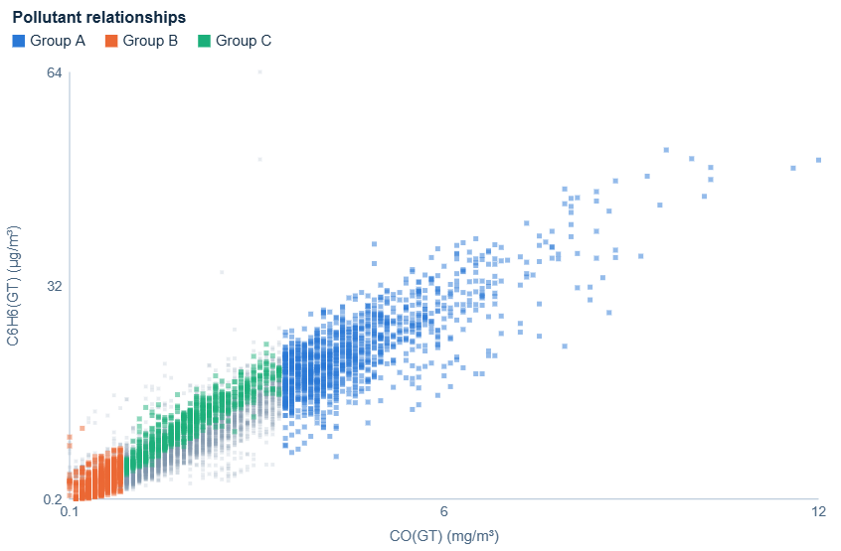
- CO against C6H6, coloured by group.
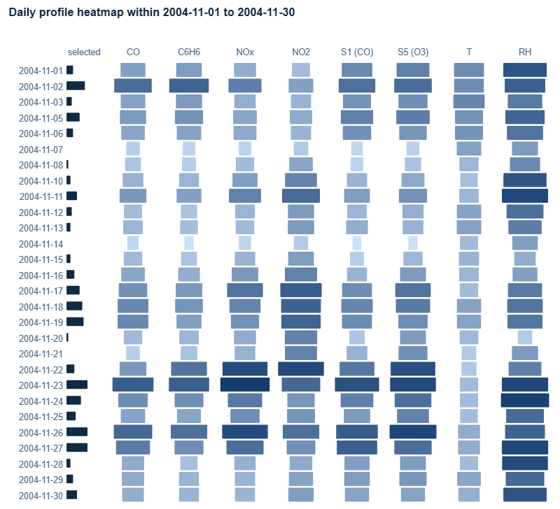
- Daily heatmap for November 2004 with the CO ≥ 3.5 brush active. The left bar counts high-CO hours per day.

Robustness of the Brushes
The brush positions are our visual choices, not exact boundaries, because the data is continuous. We moved each brush in both directions and read the group panel again (Table II). The group sizes and percentages change, but the patterns stay the same. A always has the morning and evening peaks and almost no hours at night, on Sundays or in August; B is always night-time and more common on Sundays; C is always a summer daytime group; and D is always a winter group concentrated at night and in the morning.
- Effect of Moving Each Brush (Lower / Used / Higher)
Group | Brush | Hours | Share of hours in selected slots
A | CO ≥ 3.0 / 3.5 / 4.0 | 1,692 / 1,172 / 814 | 08:00: 49 / 36 / 26%; 19:00: 63 / 51 / 41%; Sunday: 7 / 4 / 3%; 04:00 and Aug 2004: 0% in all
B | CO ≤ 0.7, NOx ≤ 70 / 0.9, 90 / 1.1, 110 | 553 / 855 / 1,231 | 04:00: 51 / 64 / 74%; 19:00: 0 / 1 / 3%; Sunday: 16 / 24 / 35% vs Wednesday: 5 / 8 / 11%
C | T ≥ 24, RH ≤ 40 / 26, 35 / 28, 30 | 1,221 / 906 / 646 | 14:00: 36 / 30 / 24%; 04:00: 1 / 0 / 0%; Jul 2004: 64 / 53 / 42%; Nov 2004 and Feb 2005: 0% in all
D | T ≤ 8 / 10 / 12 | 999 / 1,431 / 1,989 | 04:00: 28 / 34 / 47% vs 14:00: 5 / 10 / 16%; Feb 2005: 61 / 78 / 90%; Jul 2004: 0% in all

Limitations
Groups defined by high CO and C6H6 reflect one traffic signal, and C6H6 depends on a temperature-sensitive sensor. The sensors also drift, so seasonal differences on the S1 and S5 axes are partly instrumental. The groups can overlap: A and C share 102 hours and B and C share 97, while A and B do not overlap. Finally, because only complete hours are used, months with analyser gaps such as October 2004 have fewer hours, and the 03:00 slot has very few complete hours.

Task 2

Temporal Views
To follow the groups over time, we added three linked views to the same tool. They use the groups from Task 1; a “Restore Task 1 groups” button recreates them exactly, with Group D as the current selection.
- A membership matrix for each group, with months as rows and hours of day as columns. The colour of a cell is the share of complete hours in that month and hour that belong to the group, from light grey (0%) to the group colour (100%). Hatched cells have no complete hours and a dot marks cells with fewer than five. Reading down a column shows one hour of day changing group over the year.
- A monthly profile for each group, with months as rows and attributes as columns. Red means the group’s median is higher than the other hours in the same month, blue means lower and grey means no difference; the numbers are the group medians. Comparing within each month removes the seasonal level, so the colours show what makes the group different at that time. Months with fewer than five group hours are left blank.
- Monthly parallel coordinates: one small plot per month with the same axes, group lines and group medians, so the shape of each bundle can be compared month by month as small multiples [5].
The matrix keeps both time scales visible at once: the daily cycle across and the seasons down. The profile uses a diverging blue–grey–red scale because a difference has a natural zero. All views use the same axis order and scaling as Task 1, so a pattern seen in one view can be checked in the others.

Changes in Group Membership
Fig. 6 shows that the membership of every group changes during the year:
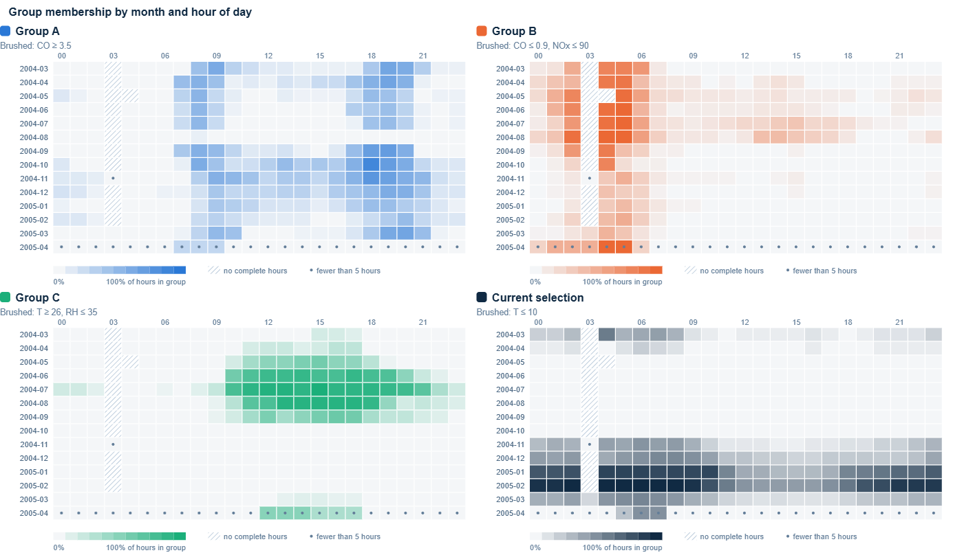
- Membership matrices (month × hour of day) for Groups A, B and C and the cold-hours selection (D).
- Group A: from March to July 2004 only the two rush-hour peaks belong to A. In August 2004 the group almost disappears (1 of 408 hours). From November to February midday hours join it (11:00–16:00 rises from 5% to 20%) and so do late-night hours (00:00–02:00, from 1% to 8%), while the rush-hour peaks hardly change (43% in spring and summer, 42% in winter). By March 2005 the midday hours have left again (2%).
- Group B: its core is 04:00–05:00 in every month, but 99% of those hours belong to B in July–August against 40% in November–February. In July–August daytime hours also join (23% of 10:00–17:00, against 1% in winter).
- Group C: in April–May it covers midday only (38% of 12:00–16:00, almost nothing after 19:00). In June–August it widens to 77% of 10:00–21:00. It is absent from October to February and returns at midday in March–April 2005.
- Group D: it covers 71% of all hours in January–February, but in March–April 2004 only nights and mornings (21% of 00:00–08:00 against 3% of 12:00–17:00).

Changes in the Defining Attributes
The monthly profiles (Figs. 7–9) show that the combination of attributes that makes a group different also changes:
- Group A: from March to July it is mainly a CO, C6H6 and S1 group, with NOx only moderately raised (median 227–296 ppb). From September NOx becomes much more important (506–733 ppb, darker red), and NO2 and S5 also rise, with the highest NO2 median in February 2005 (221 µg/m³). In the monthly parallel coordinates (Fig. 10) the median of A dips at the NOx axis in spring and summer but stays high across NOx in autumn and winter. In June and July A also has lower RH than the other hours.
- Group B: from March to September it is defined mainly by lower CO, C6H6 and S1, while NOx and NO2 are only a little lower than usual. In August 2004 the row is almost grey, so B hardly differs from the other August hours; this matches B spreading into the daytime that month. From November to February the strongest blue is on NOx, NO2 and S5, so in winter the clean hours are defined by low nitrogen oxides rather than CO.
- Group C: in March–April of both years it is strongly defined by high T and low RH, which marks rare warm, dry spells. In June–August these differences fade because all hours are warm, and in September higher NOx and NO2 (329 ppb and 145 µg/m³) join the profile.
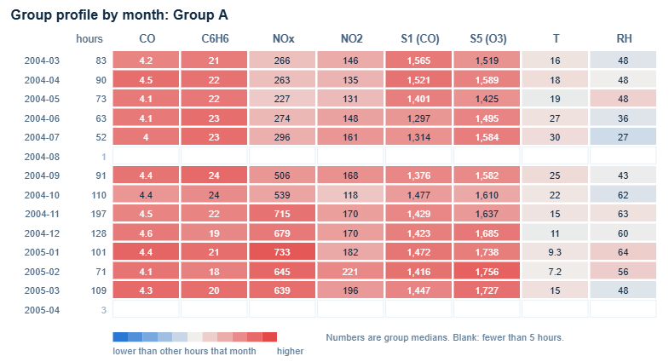
- Monthly profile of Group A.
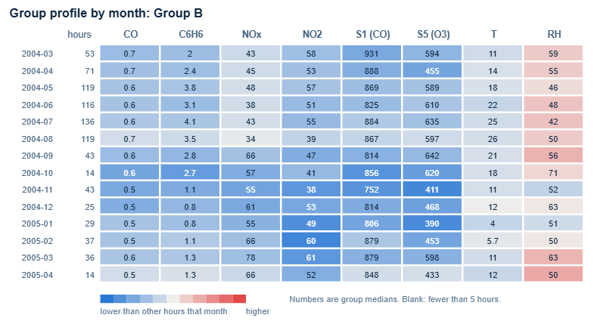
- Monthly profile of Group B.
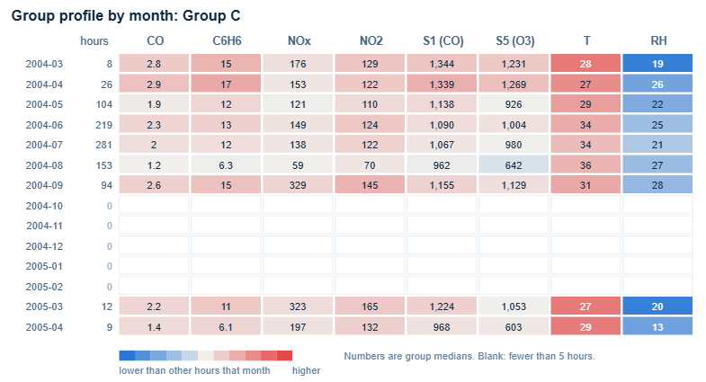
- Monthly profile of Group C.
For Group D, the cold hours, low T and high RH define the group in November and in March–April 2004, but in January–February D covers most hours, so it hardly differs from the rest of the month.
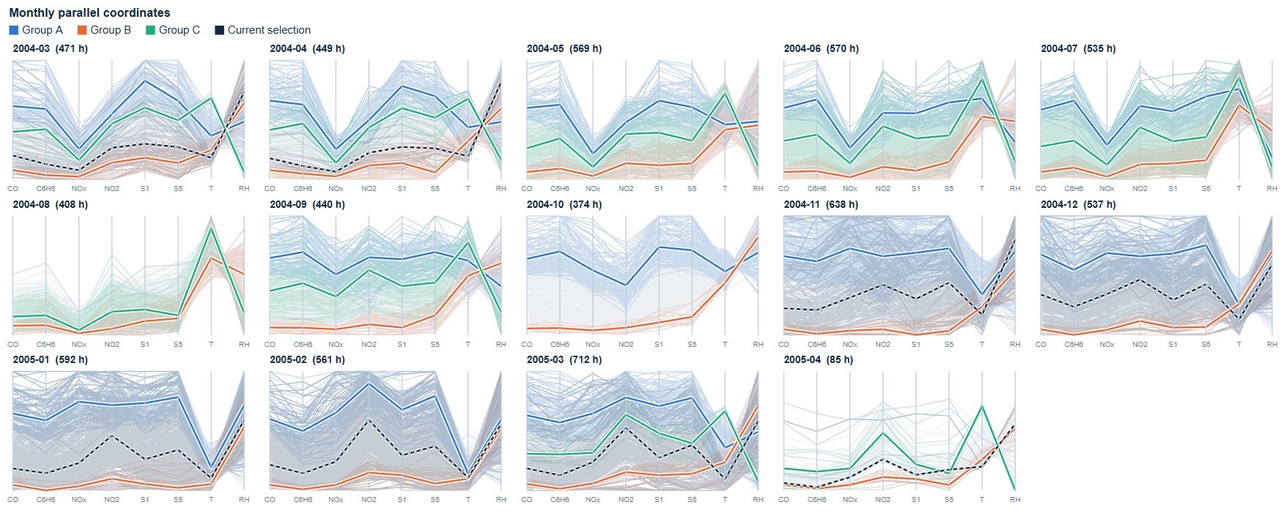
- Monthly parallel coordinates. Thick lines are group medians for each month; the dashed line is Group D.

Summary and Limitations
Both the membership and the defining combination change over the year. The biggest change is between summer and autumn 2004: in August Group A almost disappears and Group B spreads into the daytime, and from September Group A becomes led by NOx and starts to take in midday hours. Task 3 looks at this period. Some of the change on the sensor axes (S1, S5) may come from sensor drift. Months with long analyser gaps, such as October 2004, and April 2005, which has only 85 complete hours, are based on fewer hours.

Task 3

A. Critical Moment Identification
Building on Task 2, we investigated the transition from August to September 2004, when Group A (CO ≥ 3.5 mg/m³) re-emerged after being almost absent in August. Seven-day windows were compared before and after candidate dates, retaining days with at least 18 complete hourly observations. The window beginning on 20 September showed an 11.41-percentage-point increase in Group A membership, motivating further hourly investigation.
At 17:00 on 20 September 2004, CO increased from 2.6 to 5.0 mg/m³ (+92.3%) and NOx from 280 to 505 ppb (+80.4%) within one hour. The observation simultaneously entered Group A. Both pollutant values exceeded the 90th percentile of the corresponding hour on other September weekdays. This combination of an abrupt multivariate increase and a change in group membership supports selecting 17:00 as the critical moment, although the broader weekday pattern remains an important alternative explanation.
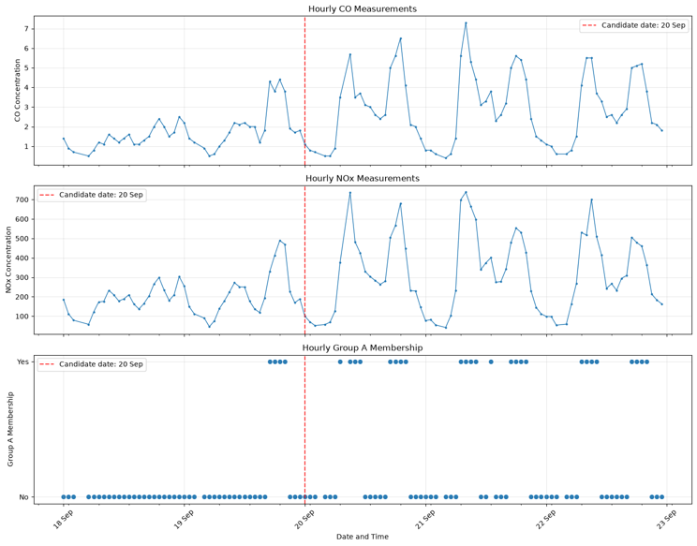
Fig. 11. Hourly changes in CO, NOx and Group A membership around the identified critical moment.
As shown in Fig. 11, the simultaneous increases in CO and NOx, together with the transition into Group A, provide visual evidence of an abrupt change in the pollution profile.

B. Environmental Context
At the critical moment, temperature was 34.1°C and relative humidity was 23.0%, compared with September weekday medians of 28.0°C and 28.8% at the same hour. However, temperature and humidity changed by only −0.2°C and −0.2 percentage points between 16:00 and 17:00, respectively. The sharp pollution increase therefore did not coincide with an equally abrupt environmental change. These observations motivate an exploratory what-if analysis but do not establish environmental causation.
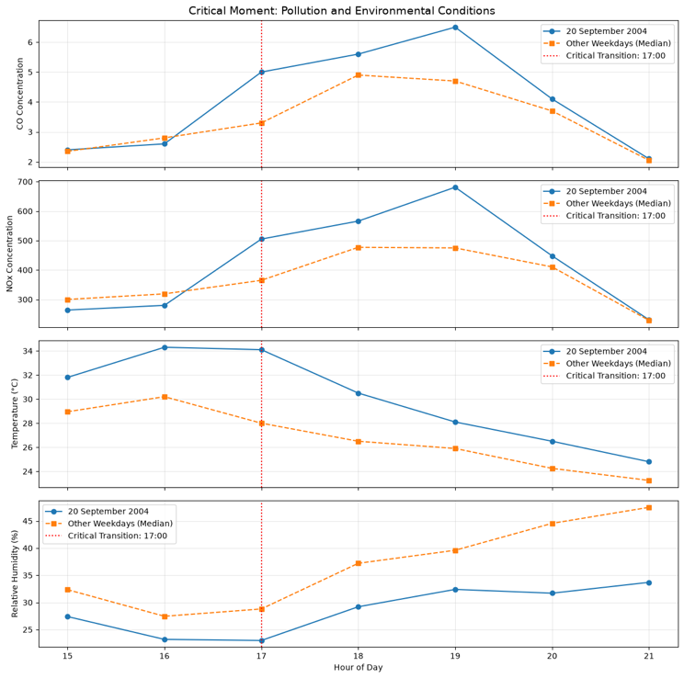
Fig. 12. Observed pollutant and environmental conditions on 20 September 2004 compared with weekday medians.
Figure 12 further illustrates that the abrupt increases in CO and NOx were not accompanied by comparable changes in temperature or relative humidity. This contrast suggests that the observed pollution transition cannot be adequately explained by the immediate changes in these two environmental variables alone.

C. What-if Scenario Analysis
Random Forest regression models were trained to estimate CO and NOx using temperature, relative humidity, hour-of-day cyclical encodings and day of week. The critical date was excluded from model development, and a chronological training–testing split was applied. Nine hypothetical scenarios combined temperature changes of −2, 0 and +2°C with relative-humidity changes of −5, 0 and +5 percentage points, holding temporal features constant.
An interactive Plotly visualisation allows users to switch between humidity scenarios and compare direct model predictions, baseline-anchored estimates and historically observed means across temperature changes. The Group A threshold and actual CO concentration provide reference lines for interpreting whether each scenario crosses the original group boundary.
Across the nine scenarios, estimated CO generally decreased as temperature increased, although the magnitude varied across humidity conditions and estimation methods. The interactive visualisation reveals substantial disagreement between direct predictions, baseline-anchored estimates and historical observations (Fig. 13). These differences indicate that scenario interpretation is sensitive to the estimation approach rather than environmental adjustments alone.
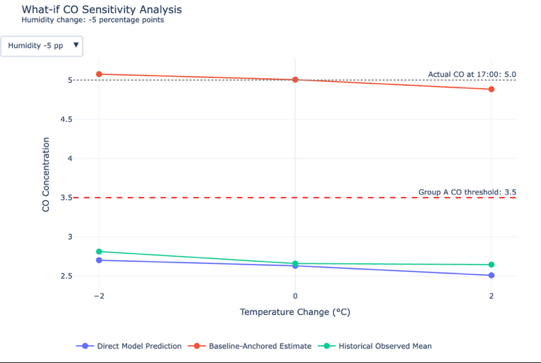
Figure 13(a). What-if CO Sensitivity Analysis under Reduced Relative Humidity (−5 Percentage Points).
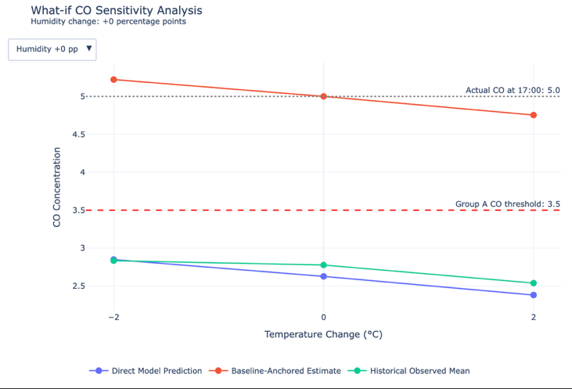
Figure 13(b). What-if CO Sensitivity Analysis under Unchanged Relative Humidity (0 Percentage Points).
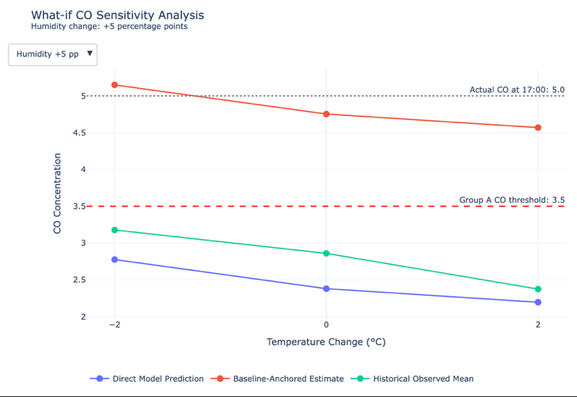
Figure 13(c). What-if CO Sensitivity Analysis under Increased Relative Humidity (+5 Percentage Points).
Figures 13(a)–(c) illustrate how estimated CO concentrations vary under three relative-humidity scenarios. Across all nine temperature–humidity combinations, direct model predictions and historical observed means remain below the Group A threshold of 3.5 mg/m³, whereas baseline-anchored estimates remain above it. Although the baseline-anchored estimates suggest that Group A membership could be preserved under the tested scenarios, this conclusion is sensitive to the estimation method. The substantial underprediction of the observed critical event by the direct model further limits confidence in the scenario projections. Therefore, the results should be interpreted as exploratory sensitivity estimates rather than evidence that changes in temperature or humidity would causally preserve the original pollution pattern.

D. Reliability, Group Preservation and Limitations
The predictive reliability of the what-if analysis was assessed using a chronological test set. The full models achieved R² values of 0.404 for CO and 0.145 for NOx, compared with 0.418 and 0.280 for the corresponding time-only models. Adding temperature and relative humidity therefore did not improve predictive performance on this test period, limiting confidence in the environmental sensitivity estimates.
At the critical moment, the CO model predicted 2.63 mg/m³ against the observed 5.0 mg/m³, corresponding to an absolute percentage error of 47.47%. As shown in Fig. 13, all nine direct predictions remained below the Group A threshold of 3.5 mg/m³, whereas baseline-anchored estimates remained above it (4.57–5.22 mg/m³). The contrasting results indicate that Group A membership preservation is sensitive to the estimation baseline and cannot be established confidently. Although both CO and NOx models were evaluated, the preservation analysis focuses on CO because it defines Group A membership; therefore, changes in the broader pollution profile remain uncertain.
Historical comparisons provided at least ten similar observations for six of the nine scenarios, while Group A proportions varied considerably. Historical observed means also remained below the threshold across the scenarios. These findings provide contextual evidence but do not validate the hypothetical outcomes. Furthermore, the threshold-based analysis evaluates Group A membership rather than preservation of its complete multivariate pollution profile.
Overall, the visual analysis identifies an abrupt pollution transition, but the what-if results should be interpreted as exploratory sensitivity estimates rather than causal predictions. Model uncertainty, limited environmental predictive contribution and uneven historical support restrict the strength of conclusions about Group A preservation.

Task 4
[Evaluation of the visual analytic tool to be added.]

References
- S. De Vito, “Air Quality,” UCI Machine Learning Repository, 2008, doi: 10.24432/C59K5F.
- S. De Vito, E. Massera, M. Piga, L. Martinotto, and G. Di Francia, “On field calibration of an electronic nose for benzene estimation in an urban pollution monitoring scenario,” Sensors and Actuators B: Chemical, vol. 129, no. 2, 2008.
- A. Inselberg, “The plane with parallel coordinates,” The Visual Computer, vol. 1, no. 2, pp. 69–91, 1985.
- B. Shneiderman, “The eyes have it: A task by data type taxonomy for information visualizations,” in Proc. IEEE Symp. Visual Languages, 1996, pp. 336–343.
- E. R. Tufte, The Visual Display of Quantitative Information. Cheshire, CT: Graphics Press, 1983.

